User Story to Testcases Generation:

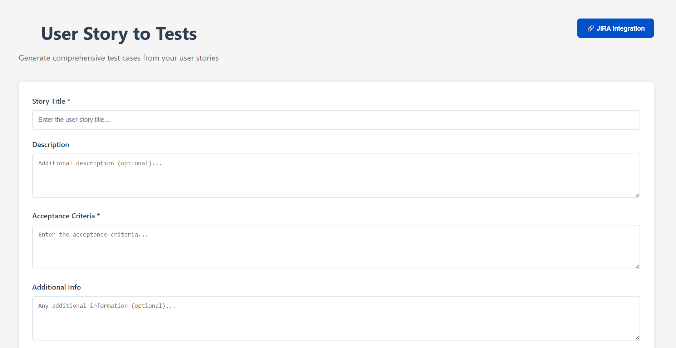

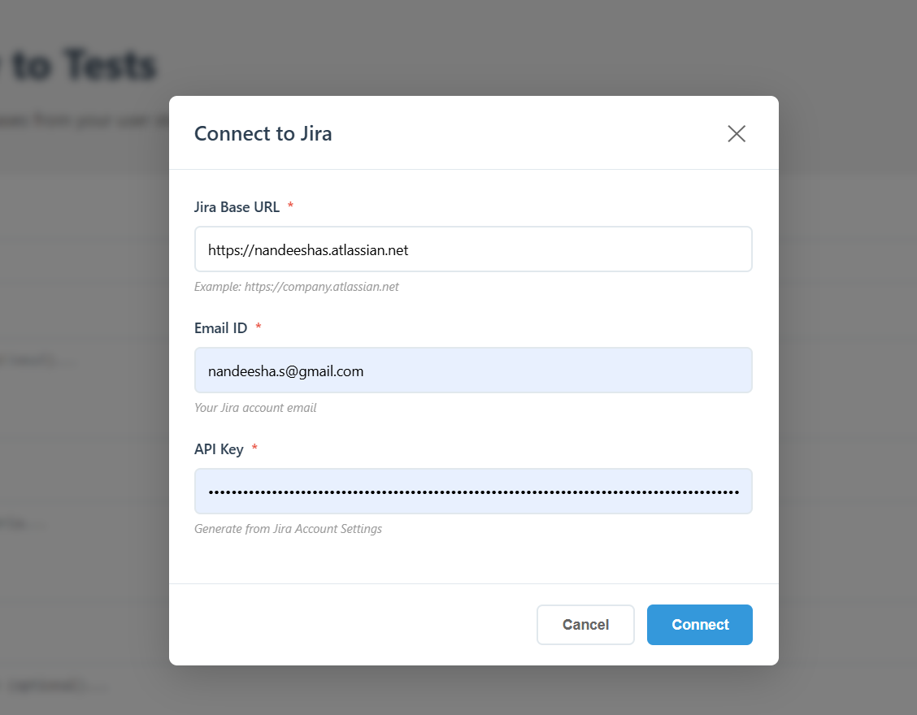

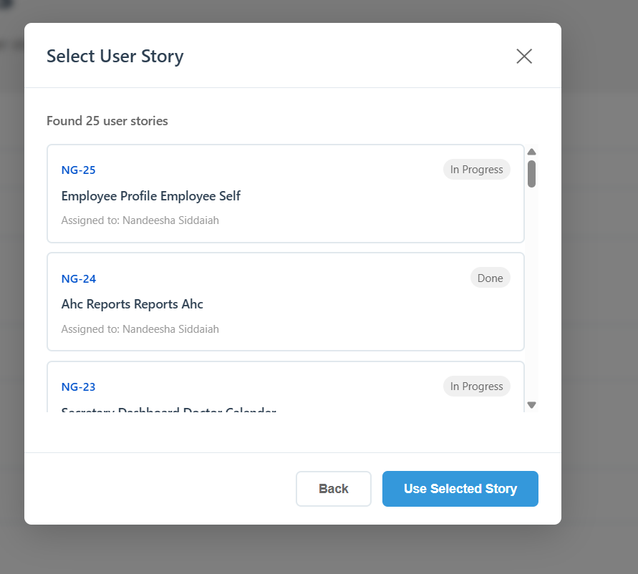

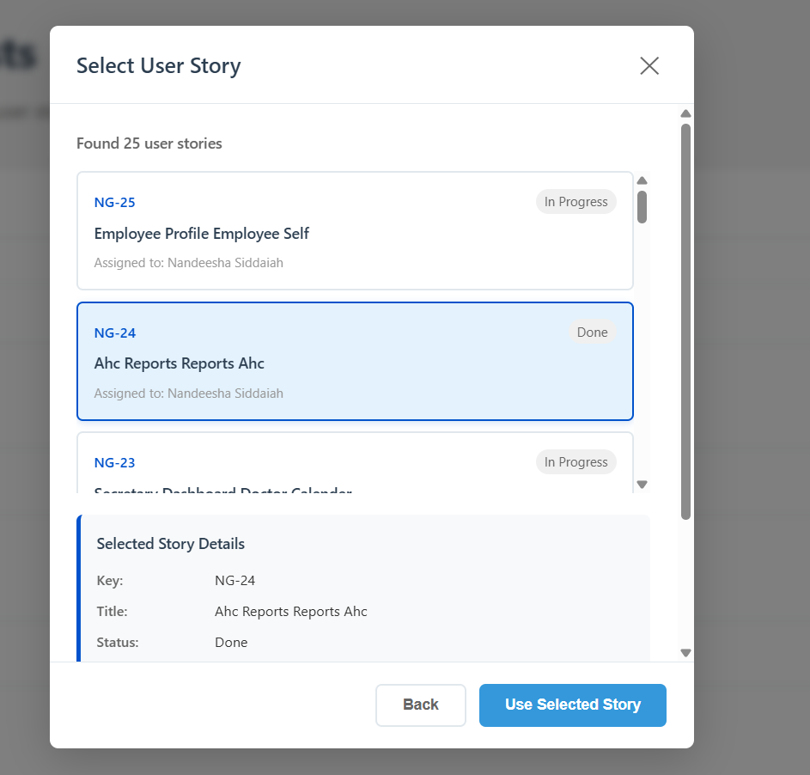

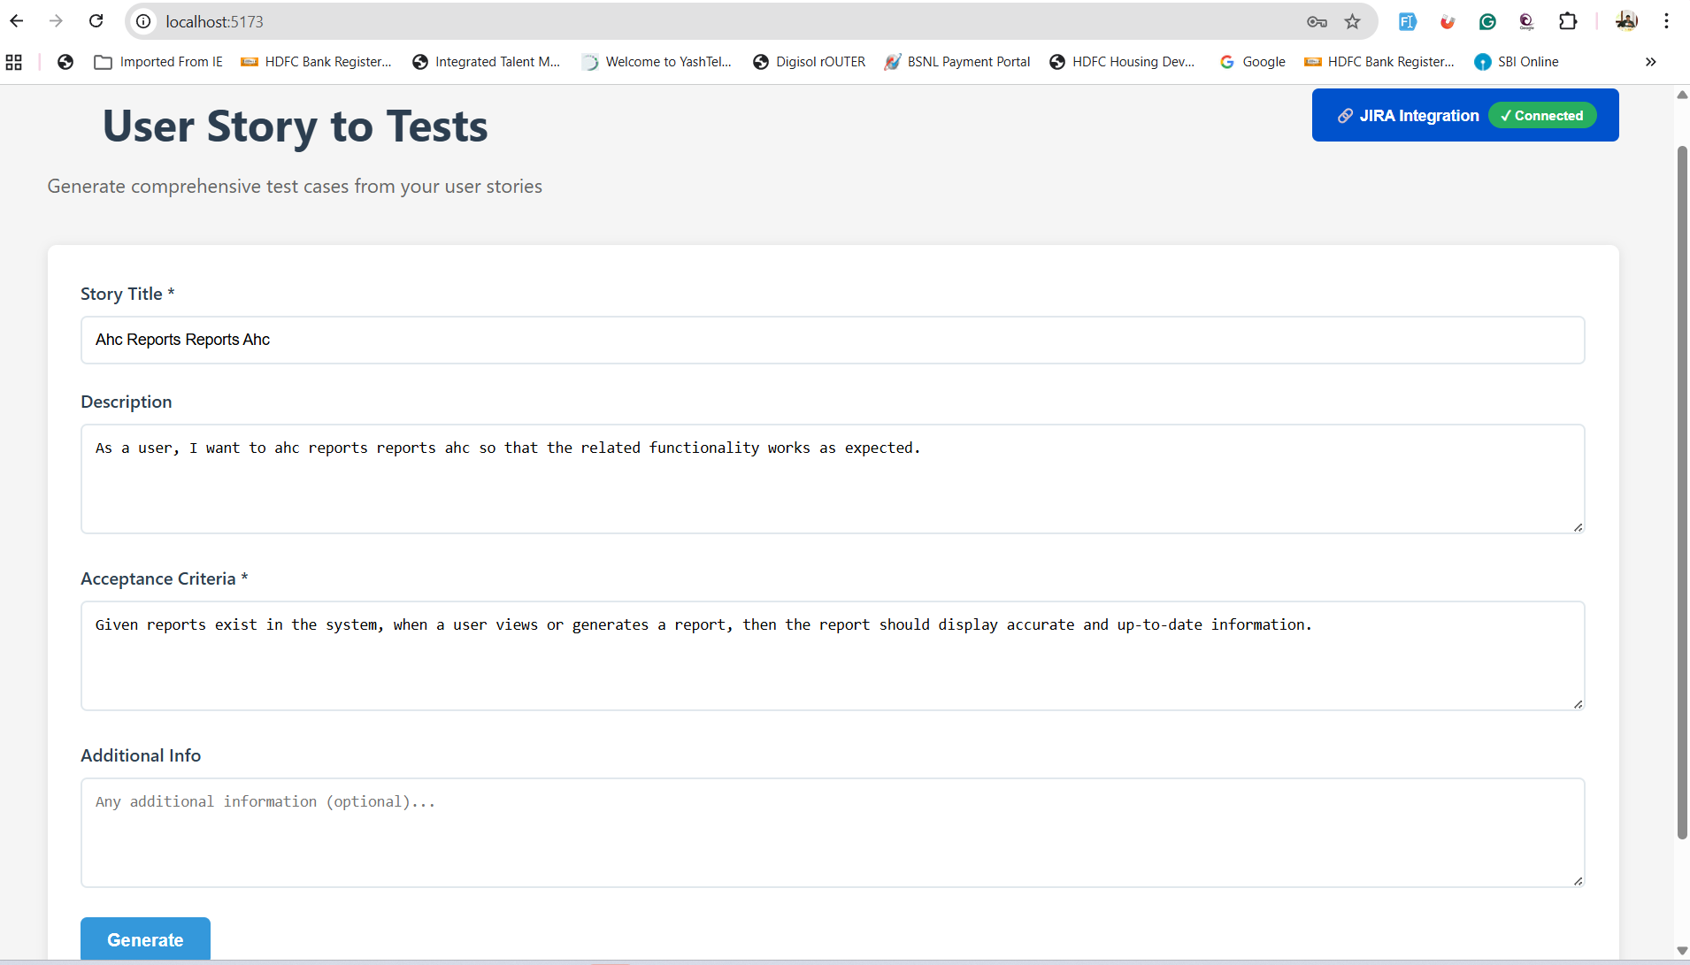

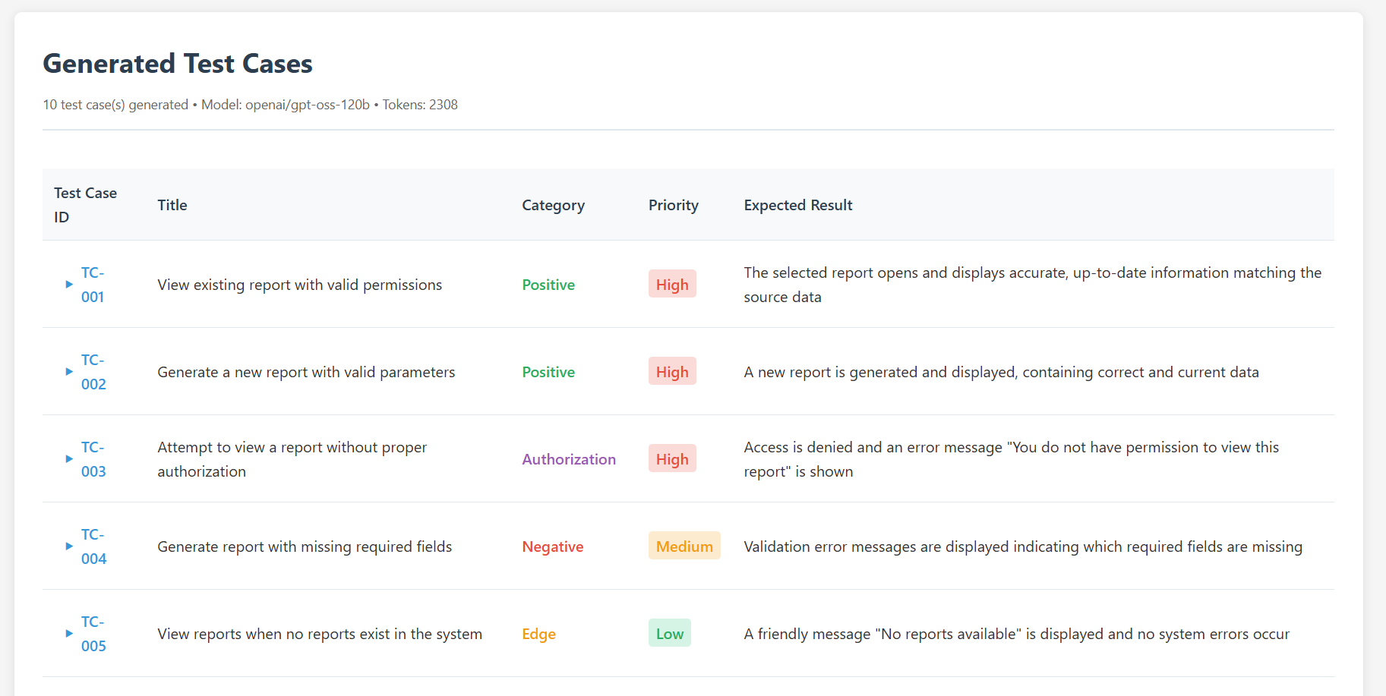

Atlassian JIRA API call Response:

{
"success": true,
"stories": [
{
"key": "NG-25",
"id": "10019",
"summary": "Employee Profile Employee Self",
"description": "As a user, I want to employee profile employee self so that the related functionality works as expected.",
"acceptanceCriteria": "Given the system is operational, when the user performs the intended action, then the system should respond accurately and meet functional expectations.",
"status": "In Progress",
"issuetype": {
"name": "Story"
},
"created": "2026-02-21T09:35:41.719+0530",
"updated": "2026-02-21T09:46:17.783+0530",
"assignee": {
"displayName": "Nandeesha Siddaiah",
"emailAddress": "nandeesha.s@gmail.com"
}
},
{
"key": "NG-24",
"id": "10018",
"summary": "Ahc Reports Reports Ahc",
"description": "As a user, I want to ahc reports reports ahc so that the related functionality works as expected.",
"acceptanceCriteria": "Given reports exist in the system, when a user views or generates a report, then the report should display accurate and up-to-date information.",
"status": "Done",
"issuetype": {
"name": "Story"
},
"created": "2026-02-21T09:35:41.719+0530",
"updated": "2026-02-21T09:47:18.855+0530",
"assignee": {
"displayName": "Nandeesha Siddaiah",
"emailAddress": "nandeesha.s@gmail.com"
}
},
{
"key": "NG-23",
"id": "10008",
"summary": "Secretary Dashboard Doctor Calender",
"description": "As a user, I want to secretary dashboard doctor calender so that the related functionality works as expected.",
"acceptanceCriteria": "Given a user with valid access, when they open the dashboard, then relevant data and visualizations should be displayed correctly without delay.",
"status": "In Progress",
"issuetype": {
"name": "Story"
},
"created": "2026-02-21T09:35:41.719+0530",
"updated": "2026-02-21T09:47:20.834+0530",
"assignee": {
"displayName": "Nandeesha Siddaiah",
"emailAddress": "nandeesha.s@gmail.com"
}
},
{
"key": "NG-22",
"id": "10017",
"summary": "Masters Others Approval Setup",
"description": "As a user, I want to masters others approval setup so that the related functionality works as expected.",
"acceptanceCriteria": "Given the system is operational, when the user performs the intended action, then the system should respond accurately and meet functional expectations.",
"status": "To Do",
"issuetype": {
"name": "Story"
},
"created": "2026-02-21T09:35:41.719+0530",
"updated": "2026-02-21T09:47:24.018+0530",
"assignee": {
"displayName": "Nandeesha Siddaiah",
"emailAddress": "nandeesha.s@gmail.com"
}
},
{
"key": "NG-21",
"id": "10012",
"summary": "Employee Profile Basic Details",
"description": "As a user, I want to employee profile basic details so that the related functionality works as expected.",
"acceptanceCriteria": "Given the system is operational, when the user performs the intended action, then the system should respond accurately and meet functional expectations.",
"status": "In Progress",
"issuetype": {
"name": "Story"
},
"created": "2026-02-21T09:35:41.719+0530",
"updated": "2026-02-21T09:35:41.719+0530"
},
{
"key": "NG-20",
"id": "10007",
"summary": "Doctor Dashboard Op Dashboard",
"description": "As a user, I want to doctor dashboard op dashboard so that the related functionality works as expected.",
"acceptanceCriteria": "Given a user with valid access, when they open the dashboard, then relevant data and visualizations should be displayed correctly without delay.",
"status": "In Progress",
"issuetype": {
"name": "Story"
},
"created": "2026-02-21T09:35:41.719+0530",
"updated": "2026-02-21T09:35:41.719+0530"
},
{
"key": "NG-19",
"id": "10006",
"summary": "Reports Admin Reports Others",
"description": "As a user, I want to reports admin reports others so that the related functionality works as expected.",
"acceptanceCriteria": "Given reports exist in the system, when a user views or generates a report, then the report should display accurate and up-to-date information.",
"status": "Done",
"issuetype": {
"name": "Story"
},
"created": "2026-02-21T09:35:41.718+0530",
"updated": "2026-02-21T09:35:41.718+0530"
},
{
"key": "NG-18",
"id": "10028",
"summary": "Consultant Dashboard My Appointments",
"description": "As a user, I want to consultant dashboard my appointments so that the related functionality works as expected.",
"acceptanceCriteria": "Given a user with valid access, when they open the dashboard, then relevant data and visualizations should be displayed correctly without delay.",
"status": "In Progress",
"issuetype": {
"name": "Story"
},
"created": "2026-02-21T09:35:41.718+0530",
"updated": "2026-02-21T09:35:41.718+0530"
},
{
"key": "NG-17",
"id": "10016",
"summary": "Billing Execution Op Bill",
"description": "As a user, I want to billing execution op bill so that the related functionality works as expected.",
"acceptanceCriteria": "Given valid billing records, when the user initiates a billing or refund action, then the system should process and update the records accurately.",
"status": "In Progress",
"issuetype": {
"name": "Story"
},
"created": "2026-02-21T09:35:41.718+0530",
"updated": "2026-02-21T09:35:41.718+0530"
},
{
"key": "NG-16",
"id": "10027",
"summary": "Radiology Transactions Reporting Worklist",
"description": "As a user, I want to radiology transactions reporting worklist so that the related functionality works as expected.",
"acceptanceCriteria": "Given reports exist in the system, when a user views or generates a report, then the report should display accurate and up-to-date information.",
"status": "To Do",
"issuetype": {
"name": "Story"
},
"created": "2026-02-21T09:35:41.718+0530",
"updated": "2026-02-21T09:35:41.718+0530"
},
{
"key": "NG-15",
"id": "10026",
"summary": "Reports Bb Report Home",
"description": "As a user, I want to reports bb report home so that the related functionality works as expected.",
"acceptanceCriteria": "Given reports exist in the system, when a user views or generates a report, then the report should display accurate and up-to-date information.",
"status": "Done",
"issuetype": {
"name": "Story"
},
"created": "2026-02-21T09:35:41.718+0530",
"updated": "2026-02-21T09:35:41.718+0530"
},
{
"key": "NG-14",
"id": "10015",
"summary": "Doctor Activities Doctor Note",
"description": "As a user, I want to doctor activities doctor note so that the related functionality works as expected.",
"acceptanceCriteria": "Given the system is operational, when the user performs the intended action, then the system should respond accurately and meet functional expectations.",
"status": "Done",
"issuetype": {
"name": "Story"
},
"created": "2026-02-21T09:35:41.718+0530",
"updated": "2026-02-21T09:35:41.718+0530"
},
{
"key": "NG-13",
"id": "10025",
"summary": "Wards Dashboard View Request",
"description": "As a user, I want to wards dashboard view request so that the related functionality works as expected.",
"acceptanceCriteria": "Given a user with valid access, when they open the dashboard, then relevant data and visualizations should be displayed correctly without delay.",
"status": "Done",
"issuetype": {
"name": "Story"
},
"created": "2026-02-21T09:35:41.718+0530",
"updated": "2026-02-21T09:35:41.718+0530"
},
{
"key": "NG-12",
"id": "10005",
"summary": "Nurse Dashboard View Request",
"description": "As a user, I want to nurse dashboard view request so that the related functionality works as expected.",
"acceptanceCriteria": "Given a user with valid access, when they open the dashboard, then relevant data and visualizations should be displayed correctly without delay.",
"status": "In Progress",
"issuetype": {
"name": "Story"
},
"created": "2026-02-21T09:35:41.717+0530",
"updated": "2026-02-21T09:35:41.717+0530"
},
{
"key": "NG-11",
"id": "10024",
"summary": "Daycare Dashboard View Request",
"description": "As a user, I want to daycare dashboard view request so that the related functionality works as expected.",
"acceptanceCriteria": "Given a user with valid access, when they open the dashboard, then relevant data and visualizations should be displayed correctly without delay.",
"status": "Done",
"issuetype": {
"name": "Story"
},
"created": "2026-02-21T09:35:41.717+0530",
"updated": "2026-02-21T09:35:41.717+0530"
},
{
"key": "NG-10",
"id": "10014",
"summary": "Consultant Dashboard View Request",
"description": "As a user, I want to consultant dashboard view request so that the related functionality works as expected.",
"acceptanceCriteria": "Given a user with valid access, when they open the dashboard, then relevant data and visualizations should be displayed correctly without delay.",
"status": "In Progress",
"issuetype": {
"name": "Story"
},
"created": "2026-02-21T09:35:41.717+0530",
"updated": "2026-02-21T09:35:41.717+0530"
},
{
"key": "NG-9",
"id": "10013",
"summary": "Radiology Transactions Front Office",
"description": "As a user, I want to radiology transactions front office so that the related functionality works as expected.",
"acceptanceCriteria": "Given the system is operational, when the user performs the intended action, then the system should respond accurately and meet functional expectations.",
"status": "Done",
"issuetype": {
"name": "Story"
},
"created": "2026-02-21T09:35:41.717+0530",
"updated": "2026-02-21T09:35:41.717+0530"
},
{
"key": "NG-8",
"id": "10004",
"summary": "Radiology Transactions Technicians Worklist",
"description": "As a user, I want to radiology transactions technicians worklist so that the related functionality works as expected.",
"acceptanceCriteria": "Given the system is operational, when the user performs the intended action, then the system should respond accurately and meet functional expectations.",
"status": "To Do",
"issuetype": {
"name": "Story"
},
"created": "2026-02-21T09:35:41.717+0530",
"updated": "2026-02-21T09:35:41.717+0530"
},
{
"key": "NG-7",
"id": "10011",
"summary": "Doctor Activities Raise Request",
"description": "As a user, I want to doctor activities raise request so that the related functionality works as expected.",
"acceptanceCriteria": "Given the system is operational, when the user performs the intended action, then the system should respond accurately and meet functional expectations.",
"status": "Done",
"issuetype": {
"name": "Story"
},
"created": "2026-02-21T09:35:41.716+0530",
"updated": "2026-02-21T09:35:41.716+0530"
},
{
"key": "NG-6",
"id": "10023",
"summary": "Nurse Activities Raise Request",
"description": "As a user, I want to nurse activities raise request so that the related functionality works as expected.",
"acceptanceCriteria": "Given a nurse user, when they access ward management features, then they should be able to perform and track patient-related activities seamlessly.",
"status": "Done",
"issuetype": {
"name": "Story"
},
"created": "2026-02-21T09:35:41.716+0530",
"updated": "2026-02-21T09:35:41.716+0530"
},
{
"key": "NG-5",
"id": "10010",
"summary": "Billing Execution Deposit Refund",
"description": "As a user, I want to billing execution deposit refund so that the related functionality works as expected.",
"acceptanceCriteria": "Given valid billing records, when the user initiates a billing or refund action, then the system should process and update the records accurately.",
"status": "In Progress",
"issuetype": {
"name": "Story"
},
"created": "2026-02-21T09:35:41.716+0530",
"updated": "2026-02-21T09:35:41.716+0530"
},
{
"key": "NG-4",
"id": "10022",
"summary": "Reports View Reports Others",
"description": "As a user, I want to reports view reports others so that the related functionality works as expected.",
"acceptanceCriteria": "Given reports exist in the system, when a user views or generates a report, then the report should display accurate and up-to-date information.",
"status": "In Progress",
"issuetype": {
"name": "Story"
},
"created": "2026-02-21T09:35:41.716+0530",
"updated": "2026-02-21T09:35:41.716+0530"
},
{
"key": "NG-3",
"id": "10021",
"summary": "Daycare Nurse Activities Raise",
"description": "As a user, I want to daycare nurse activities raise so that the related functionality works as expected.",
"acceptanceCriteria": "Given a nurse user, when they access ward management features, then they should be able to perform and track patient-related activities seamlessly.",
"status": "In Progress",
"issuetype": {
"name": "Story"
},
"created": "2026-02-21T09:35:41.715+0530",
"updated": "2026-02-21T09:35:41.715+0530"
},
{
"key": "NG-2",
"id": "10020",
"summary": "Wards Dashboard Nurse Activities",
"description": "As a user, I want to wards dashboard nurse activities so that the related functionality works as expected.",
"acceptanceCriteria": "Given a user with valid access, when they open the dashboard, then relevant data and visualizations should be displayed correctly without delay.",
"status": "To Do",
"issuetype": {
"name": "Story"
},
"created": "2026-02-21T09:35:41.714+0530",
"updated": "2026-02-21T09:35:41.714+0530"
},
{
"key": "NG-1",
"id": "10009",
"summary": "Consultant Dashboard My Inpatients",
"description": "As a user, I want to consultant dashboard my inpatients so that the related functionality works as expected.",
"acceptanceCriteria": "Given a user with valid access, when they open the dashboard, then relevant data and visualizations should be displayed correctly without delay.",
"status": "To Do",
"issuetype": {
"name": "Story"
},
"created": "2026-02-21T09:35:41.712+0530",
"updated": "2026-02-21T09:35:41.712+0530"
}
],
"count": 25
}

